Name: _________________________ Period: _____
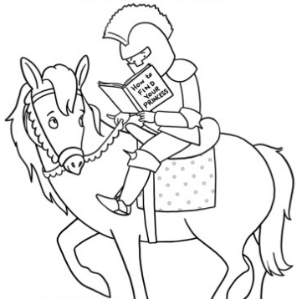
Lone Peak Reading Challenge: My Starter List
It’s a knight. Reading.
Spend the rest of the class period finding potential books you could read for our Reading Challenge. You’ll notice there are specific tasks that you must do so that your list is rich with variety. Just because you write a book down doesn’t mean you have to read it, but this will be a list for you to refer to if you get stuck and don’t know what to read next.
Complete this by the end of the period and turn it in to me (you’ll get it back.)
Pick at least 3 genres and use the book tables to find at least 5 books that look interesting.
Genre Title Author
1.________________ _______________________________ ____________________
2.________________ _______________________________ ____________________
3.________________ _______________________________ ____________________
4.________________ ______________________________ ____________________
5.________________ _______________________________ ____________________
6.________________ _______________________________ ____________________
7.________________ _______________________________ ____________________

Get recommendations from at least 5 different classmates (include title and classmate recommending the book).
Title Who Recommended It?
1.____________________________________________ _______________________
2.____________________________________________ _______________________
3.____________________________________________ _______________________
4.____________________________________________ _________________________
5.____________________________________________ _________________________
6.____________________________________________ _________________________
7.____________________________________________ _________________________

List 2 of your interests and use the online catalog to find a nonfiction book for each interest.
Interest Title Author
1._________________ ______________________________ ___________________
2._________________ ______________________________ ___________________

Use the online catalog to find at least 2 books that are similar to a book you have enjoyed before.
Title Author
1.______________________________________________ _______________________
2.______________________________________________ _______________________
3.______________________________________________ _______________________
4.______________________________________________ _______________________
5.______________________________________________ _______________________

Explore the Library—the shelves, the lists, the catalog tools, etc. to find at least 3 other books that look interesting.
Genre Title Author
1.________________ _______________________________ ____________________
2.________________ _______________________________ ____________________
3.________________ _______________________________ ____________________
4.________________ ______________________________ ____________________
5.________________ _______________________________ ____________________
6.________________ _______________________________ ____________________
7.________________ _______________________________ ____________________

